***COSMIC MICROWAVE BACKGROUND***

* Cosmic Microwave Radiation is the microwave radiation that fills all of the space. It is the oldest radiation of the universe that we have observed till this date. It carries information about the early universe when it was only 379,000 years old. CMB’s radiation was first recorded by two scientists namely Arno Allan Penzias and Robert Woodrow Wilson during their experiment on radio waves. They first thought it was some noise in their readings but after finding the same noise everywhere they thought it was something else more unique. This led to the discovery of CMB.
* The radiation of the image depicted below was captured by the planck spacecraft. The image depicts the heat map of the universe at its early stage. The orange parts are the hotter parts and the blue parts are the cooler parts. This doesn’t contradict the homogeneity of the universe because the difference in the temperature is in 0.001 of kelvin. This little anisotropic change was enough for making the universe slightly denser in some parts than others.On large scales the CMB image seems fully uniform in terms of temperature.

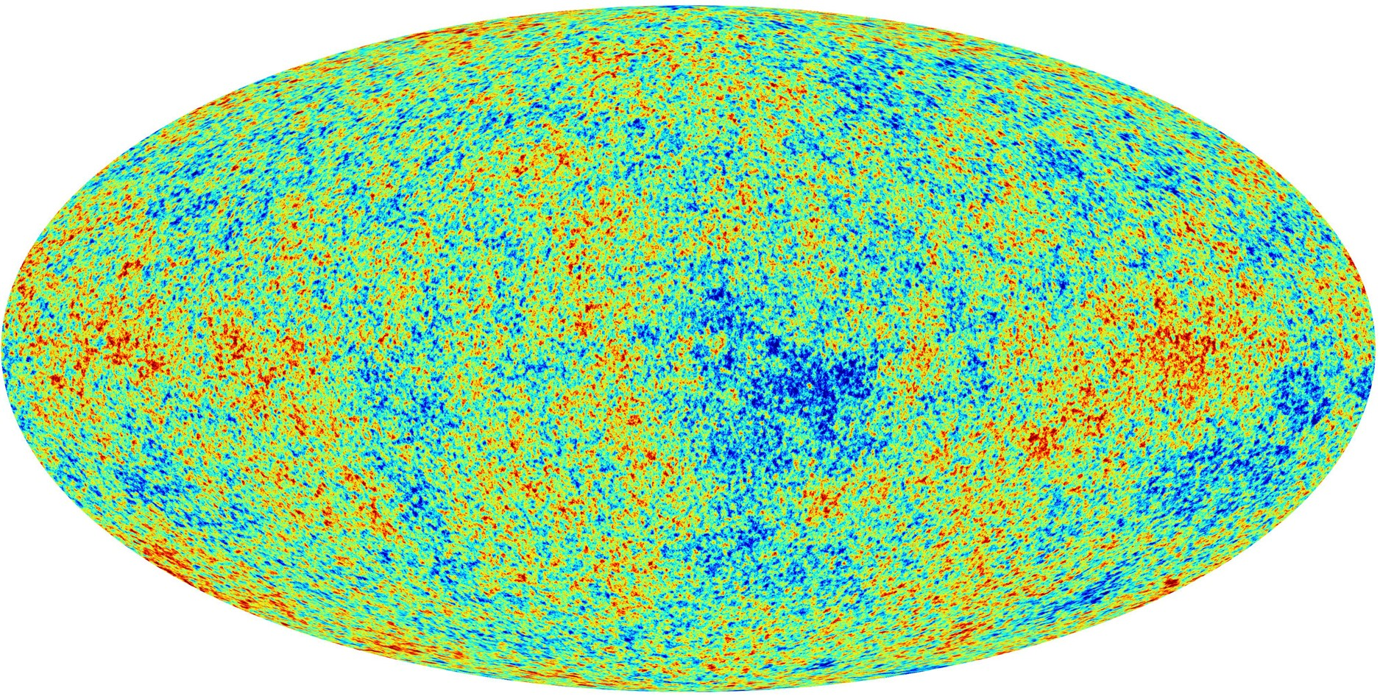

* CMB confirms the inflationary nature of the universe and gives evidence for the big bang theory. Inflation triggered sound waves that alternately compressed and rarefied regions of the plasma which contained photons,dark matter,baryonic matter. After the recombination, the pattern of density variations caused by the sound waves was frozen into CMB.By studying all of the acoustic signals in the CMB, cosmologists have estimated the age, constitution and shape of the universe.
* Sound waves that embedded the information in the CMB were formed due to tug of war between gravity of dark matter and the pressure of radiation in the slightly denser region.These sound waves were actually oscillations that contracted and expanded. During decoupling radiation could finally release itself and make the oscillation static. As the oscillation became static this caused the matter carried by those waves to be distributed according to the phase at which the oscillation stopped. The oscillation could have been stopped as maximum expansion or maximum compression. This caused different parts of the universe to have different matter density

.

* The anisotropic nature of CMB provides the existence of dark matter. If only baryonic matter existed then the radiation pressure would have dominated the gravitational pull of baryonic matter.But dark matter(which does not interact with light) existed which created the stronger gravitational pull needed for the contraction of baryonic matter into slightly denser regions.This also suggests that dark matter should have been in higher quantity in the early stages of the universe. If only baryonic matter existed then there would have been a different anisotropy for our CMB.